
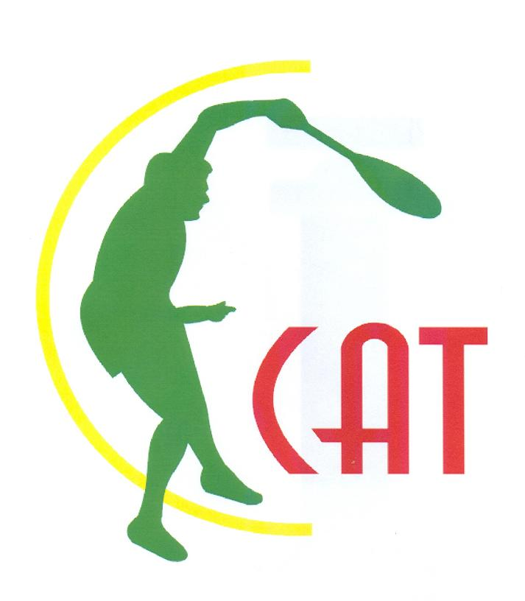

ITF/CAT PRIZE MONEY CIRCUIT 2013

ENTRY FORM

Lomé – Togo: 04 – 07 December 2013

*To be completed and returned to the concerned National Association before 03 December 2013:

The Tennis Association of ………………………………intends to send the following players to
participate in the ITF/CAT Prize Money tournament of:

Lomé – Togo: 04 – 07 December 2013

Entry deadline: 03 December 2013

 | Last Name | First Name | Ranking
 | Last Name | First Name | ATP | WTA | ITF | NATIONAL
Men’s Singles
Men’s Singles
Men’s Singles
Men’s Singles
Men’s Doubles
Men’s Doubles
Coach

The entries must be directly sent to following concerned National Association:

Fédération Togolaise de Tennis
Mme Essi DJEHA-AKUETE
Tel : +228 90 16 90 32 /+228 99 48 86 67
+228 22 21 86 58
Email : esda78@yahoo.fr

Signed:

Name:
Position:

Date:

